PICO Worksheet Example

1. Use the following categories to help define your problem and what you are looking at in simple terms
PICO: Patient/Problem, Intervention, Comparison, and Outcome. (Quantitative situation)
(remember to use your readings to help you if you are unsure)
Patient/Problem: Hospital acquired infection
Intervention: Handwashing
Comparison: No handwashing, masks, other…
Outcome: Reduced infection

2. Now use these terms from the question above to create your PICO research question so that you have a clear purpose for your search:

Does handwashing among healthcare workers reduce hospital acquired infection?

3. What type of question do you think this PICO answers?

It answers questions relating to Therapy, Intervention.
4. The table below will help you to think of the other terms that you might also like to look up when searching for evidence to help you answer your question – this is part of basic planning for a research search.

- We ask you to look up alternative terms because sometimes articles from health systems call things different names – for example, in Australia we sometimes us the term ‘community nurses’, but in the UK they often talk about ‘district nurses’ – if you only searched under ‘district nurse’ you’d miss all the articles which used the other term – you would be missing some of the picture!

Population | Intervention | Comparison  (not commonly used in actual database search strategy) | Outcome  (not commonly used in actual database search strategy)
What is your population? Main search term:  Hospital acquired infection  What other terms might have been used?  Alternative search terms:  Cross infection  Nosocomial infection | What is your intervention? Main search term:  Handwashing  What other terms might have been used?  Alternative search terms:  Hand washing  Hand disinfection  Hand scrubbing  Hand hygiene | What is your comparison? Main search term:  No Handwashing  What other terms might have been used?  Alternative search terms:  Masks  Other | What is your outcome? Main search term:  Reduced infection  What other terms might have been used?  Alternative search terms:

5. Is there a particular group of people that you want to look at? List here any inclusion criteria you might use to refine your search if you have too many papers:

Gender: ALL Age Range: ALL Publication Dates: ALL Language: ALL (preferably English or able to be translated)

6. What kind of study do you think would best answer your question? Select here which type of article you might want to access. You can also use these to refine your search if you have a lot of papers.

□ Systematic Review  □ Randomized Controlled Trial (RCT)  □ Cohort Study  □ Case-control Study/Case Series | □ Qualitative Study  □ Economic Evaluation  □ Clinical Practice Guidelines

Systematic Search Plan (this is what we call a Search Strategy)

7. Now that you have decided on WHAT you will be searching, you need to put down a plan of HOW you will search for your articles. This helps you and others to see how you got your evidence and how you made sure you got the best evidence to help you decide on your clinical action.

 | Key terms:
1 | Cross infection
2 | Hospital acquired infection
3 | Nosocomial infection
4 | Hand disinfection
5 | Handwashing
6 | Hand washing
7 | Hand scrubbing
8 | Hand hygiene
9 | No handwashing
10 | Masks
11 | Reduced infection
14 | 1 or 2 or 3
15 | 4 or 5 or 6 or 7 or 8
16 | 14 and 15
17 | TIP Consider patient/problem and intervention first when planning your search and selecting terms.
18 | TIP Not all aspects of the question need to be included in the search

8. The final step is to paste in a picture (screenshot/screengrab) of the search or generate a search strategy from your database search in word. You can do this using the Export feature in OVID SP.

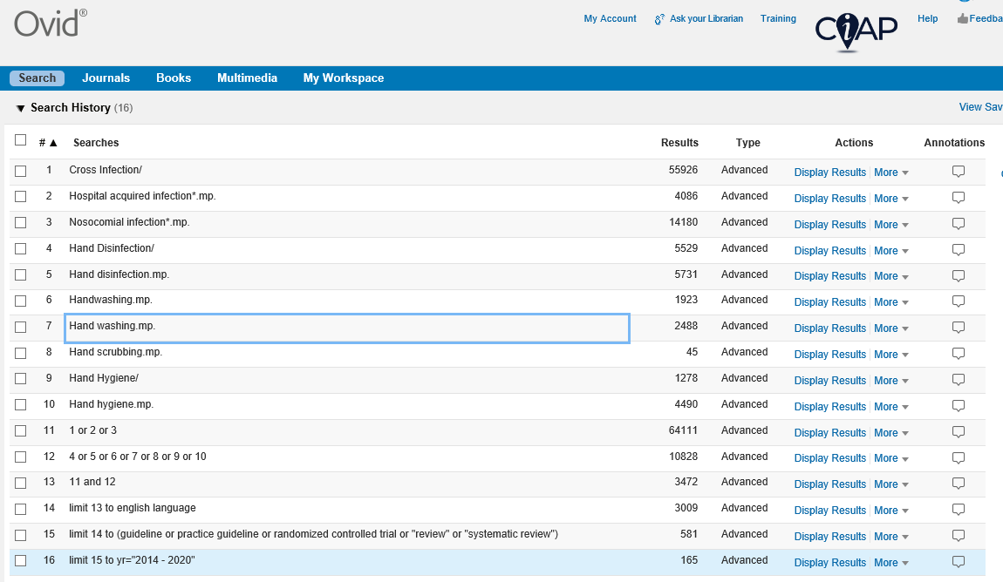

Database: MEDLINE(R) All including Epub Ahead of Print, In-Process & Other Non-Indexed Citations, Daily and Versions(R) <1946-current>
Search Strategy:
--------------------------------------------------------------------------------
1 Cross Infection/ (55926)
2 Hospital acquired infection*.mp. (4086)
3 Nosocomial infection*.mp. (14180)
4 Hand Disinfection/ (5529)
5 Hand disinfection.mp. (5731)
6 Handwashing.mp. (1923)
7 Hand washing.mp. (2488)
8 Hand scrubbing.mp. (45)
9 Hand Hygiene/ (1278)
10 Hand hygiene.mp. (4490)
11 1 or 2 or 3 (64111)
12 4 or 5 or 6 or 7 or 8 or 9 or 10 (10828)
13 11 and 12 (3472)
14 limit 13 to english language (3009)
15 limit 14 to (guideline or practice guideline or randomized controlled trial or "review" or "systematic review") (581)
16 limit 15 to yr="2014 - 2020" (165)

Note this search has been generated as a guide only and should not be viewed as comprehensive.

